Assignment 1:

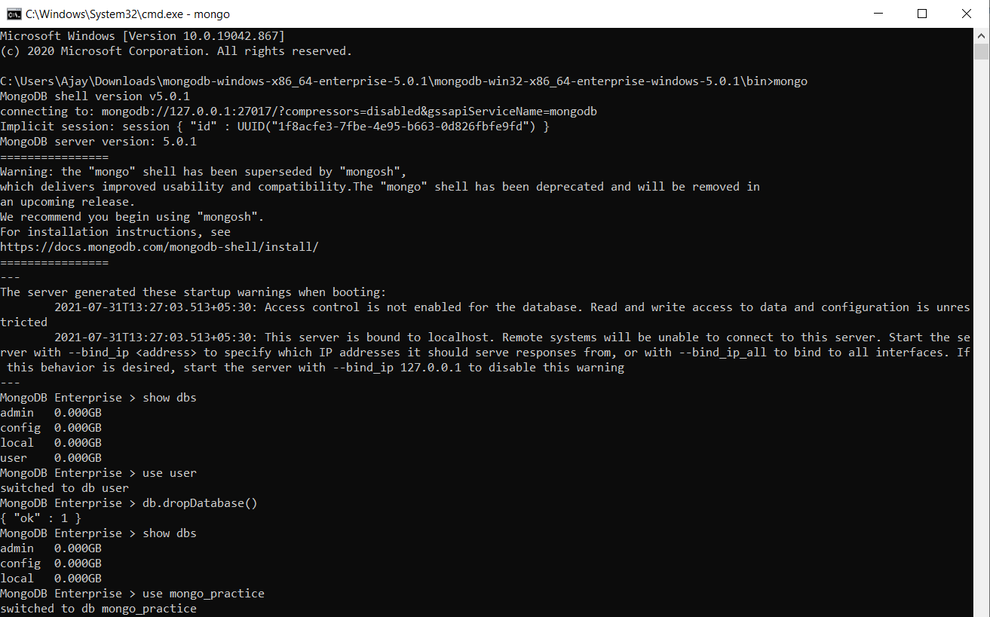Inserting Documents in movies collection in mongo_practice database:

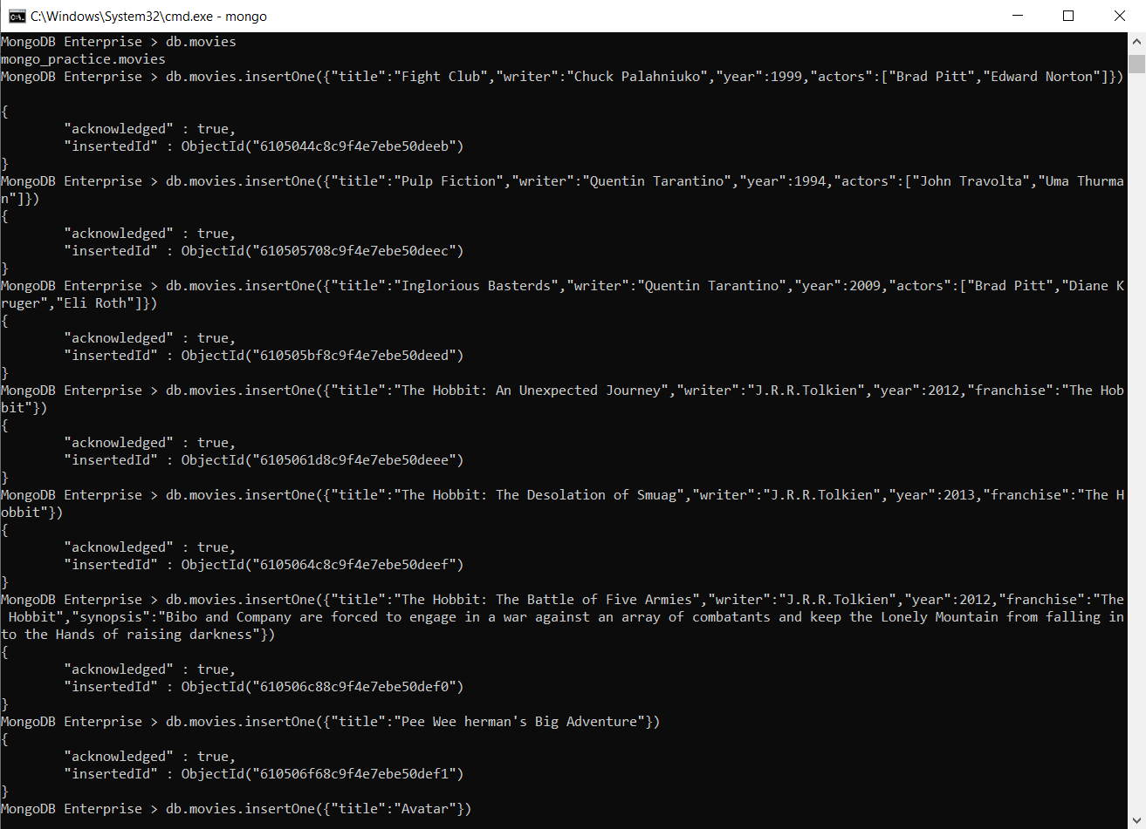

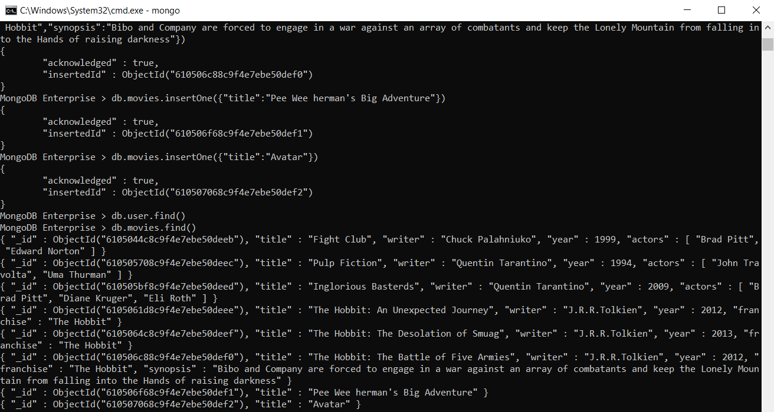Get All the Documents set to Quentin Tarantino:

Get all documents where actors include "Brad Pitt":

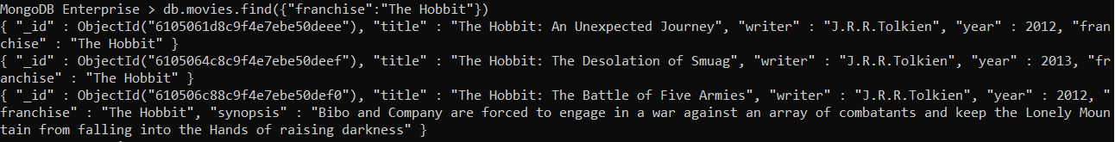Get all documents with franchise set to "The Hobbit":

Get all movies released in the 90s:

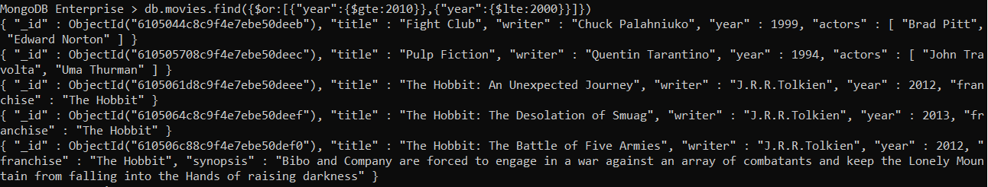Get all movies released before the year 2000 or after 2010:

Add a synopsis to "The Hobbit: An Unexpected Journey" : "A reluctant hobbit, Bilbo Baggins, sets out to the Lonely Mountain with a spirited group of dwarves to reclaim their mountain home - and the gold within it - from the dragon Smaug.":

Add a synopsis to "The Hobbit: The Desolation of Smaug" : "The dwarves, along with Bilbo Baggins and Gandalf the Grey, continue their quest to reclaim Erebor, their homeland, from Smaug. Bilbo Baggins is in possession of a mysterious and magical ring.":

Add an actor named "Samuel L. Jackson" to the movie "Pulp Fiction":

Delete the movie "Pee Wee Herman's Big Adventure"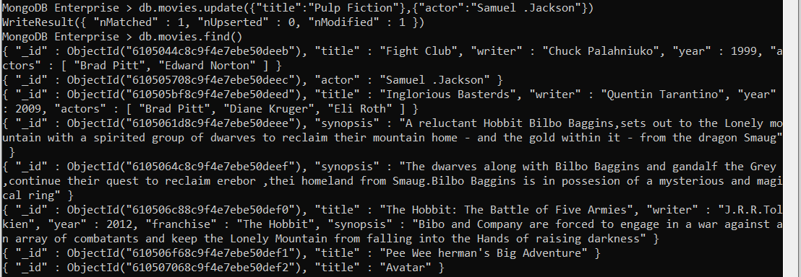, delete the movie "Avatar":



Insert the following documents into a users collection:

Insert the following documents into a posts collection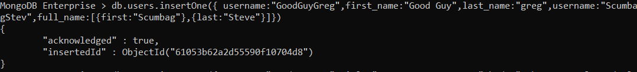:

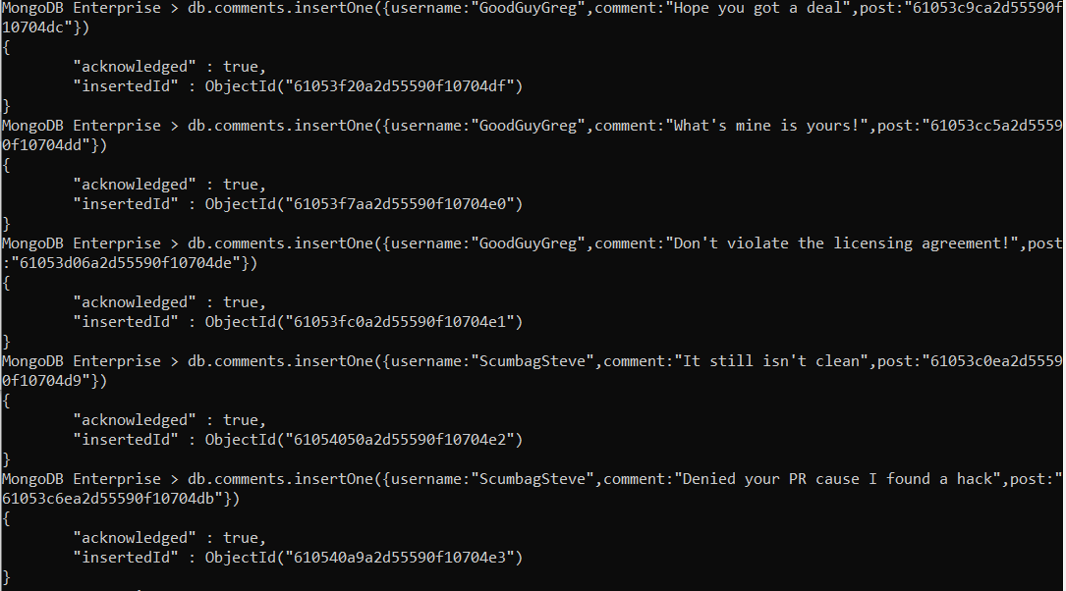Insert the following documents into a comments collection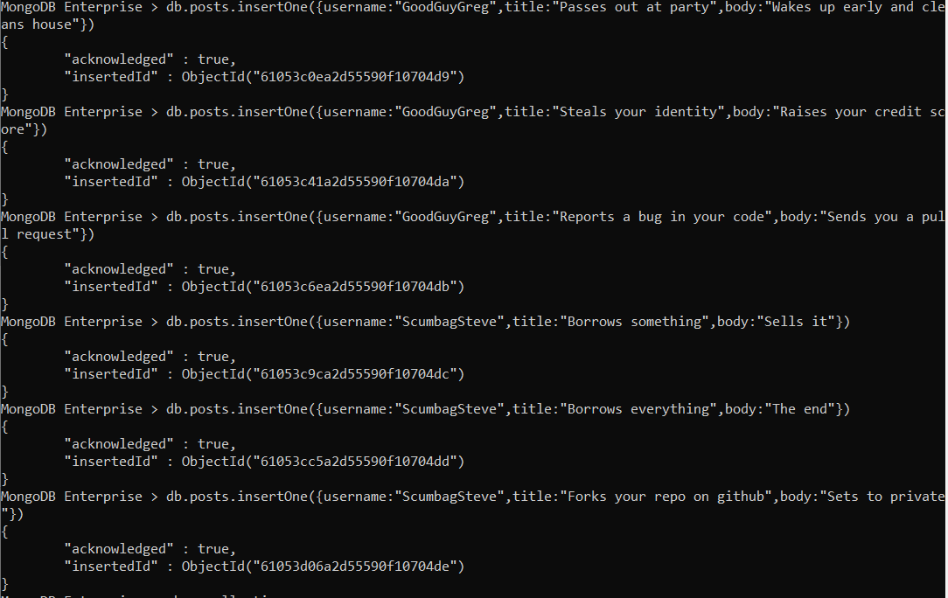:

Find all comments:

Find all posts that was authored by "GoodGuyGreg"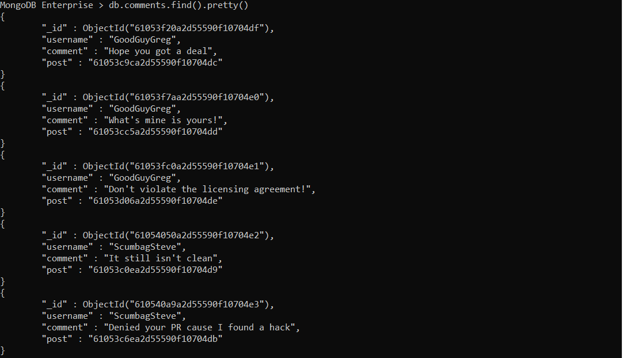:

Find all posts that was authored by "ScumbagSteve"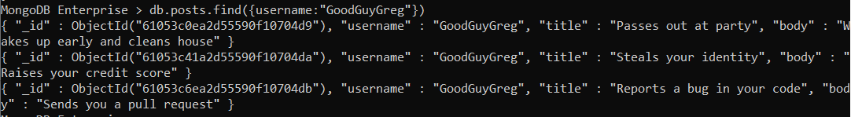:

Find all comments that was authored by "GoodGuyGreg"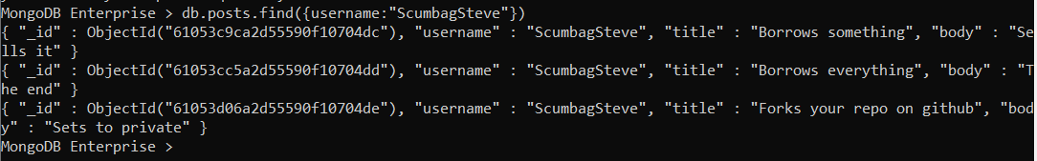:

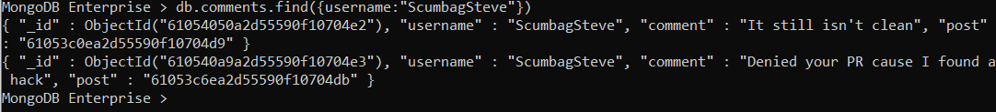Find all comments that was authored by "ScumbagSteve"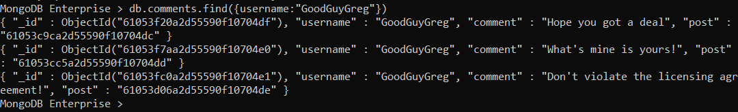:

Find all comments belonging to the post "Reports a bug in your code":

